**Activity 11 Machine Learning**

**Xulu OS 22222778**

**We have 10 Locations**

1. Admin Building

2. Engineering Block

3. Science Labs

4.Library

5. ICT Department

6.Residence A

7. Residence B

8. Cafeteria

9. Sports Complex

10. Main Entrance

**Step 1: Understand the Route Description**

* Admin Building → Library
* Library → ICT Department
* ICT Department → Engineering Block
* Engineering Block → Science Labs
* Science Labs → Cafeteria
* Cafeteria → Residence A → Residence B
* Residence B → Main Entrance
* Some students loop: Main Entrance → Admin Building
* Some go: Library → Sports Complex

**Step 2: Drawing the Directed Graph**

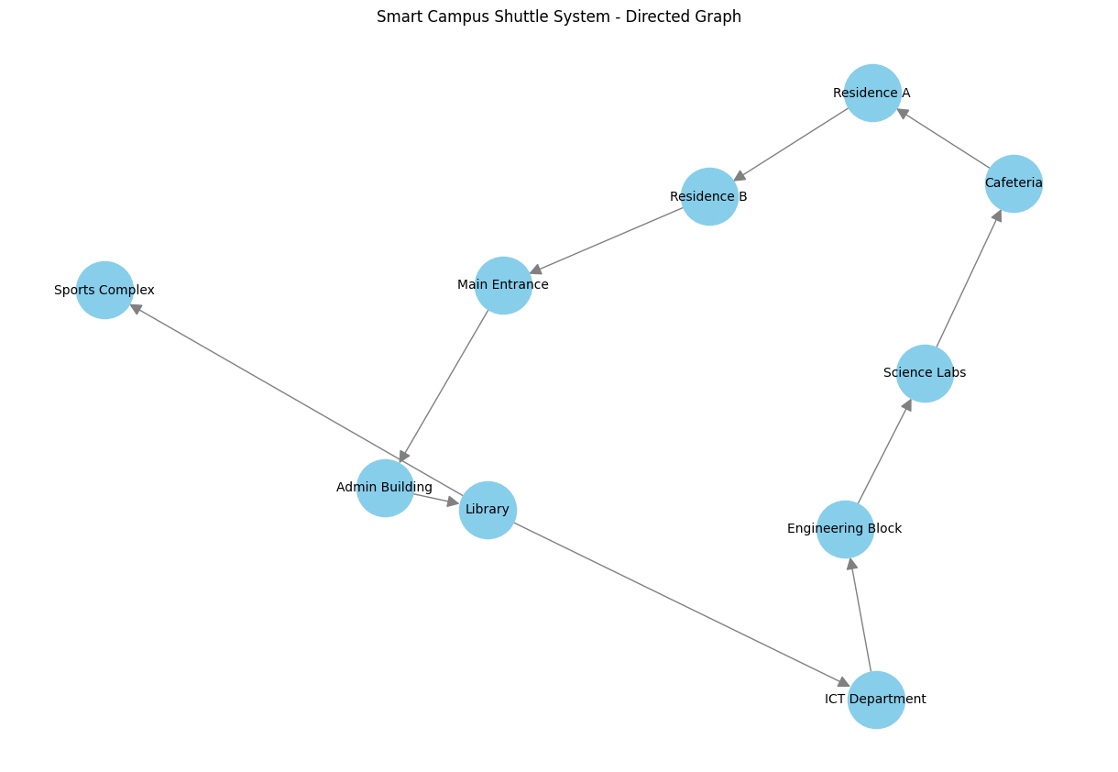

**Step 3: Creating the Adjacency Matrix**

3.1 Assigning numbers to location for indexing

| **Index** | **Location** |
| --- | --- |
| 0 | Admin Building |
| 1 | Engineering Block |
| 2 | Science Labs |
| 3 | Library |
| 4 | ICT Department |
| 5 | Residence A |
| 6 | Residence B |
| 7 | Cafeteria |
| 8 | Sports Complex |
| 9 | Main Entrance |

3.2 Edge List = [

(0, 3), Admin → Library

(3, 4), Library → ICT

(4, 1), ICT → Engineering

(1, 2), Engineering → Science Labs

(2, 7), Science Labs → Cafeteria

(7, 5), Cafeteria → Residence A

(5, 6), Residence A → Residence B

(6, 9), Residence B → Main Entrance

(9, 0), Main Entrance → Admin

(3, 8), Library → Sports Complex

]

|  |  |  |  |  |  |  |  |  |  |  |
| --- | --- | --- | --- | --- | --- | --- | --- | --- | --- | --- |
|  | **0** | **1** | **2** | **3** | **4** | **5** | **6** | **7** | **8** | **9** |
| **0** | 0 | 0 | 0 | 1 | 0 | 0 | 0 | 0 | 0 | 0 |
| **1** | 0 | 0 | 1 | 0 | 0 | 0 | 0 | 0 | 0 | 0 |
| **2** | 0 | 0 | 0 | 0 | 0 | 0 | 0 | 1 | 0 | 0 |
| **3** | 0 | 0 | 0 | 0 | 1 | 0 | 0 | 0 | 1 | 0 |
| **4** | 0 | 1 | 0 | 0 | 0 | 0 | 0 | 0 | 0 | 0 |
| **5** | 0 | 0 | 0 | 0 | 0 | 0 | 1 | 0 | 0 | 0 |
| **6** | 0 | 0 | 0 | 0 | 0 | 0 | 0 | 0 | 0 | 1 |
| **7** | 0 | 0 | 0 | 0 | 0 | 1 | 0 | 0 | 0 | 0 |
| **8** | 0 | 0 | 0 | 0 | 0 | 0 | 0 | 0 | 0 | 0 |
| **9** | 1 | 0 | 0 | 0 | 0 | 0 | 0 | 0 | 0 | 0 |

**STEP 4 Creating Adjacency List**

Adjacency List = {

"Admin Building"**:** ["Library"],

"Library"**:** ["ICT Department", "Sports Complex"],

"ICT Department"**:** ["Engineering Block"],

"Engineering Block"**:** ["Science Labs"],

"Science Labs"**:** ["Cafeteria"],

"Cafeteria"**:** ["Residence A"],

"Residence A"**:** ["Residence B"],

"Residence B"**:** ["Main Entrance"],

"Main Entrance"**:** ["Admin Building"],

"Sports Complex"**:** []